Lucky Man Cree Nation – Land Use Plan Survey

Hello LMCN Members

We need your feedback to guide future development on LMCN lands. Building on the Treaty Day community engagement for Land Use Planning, we are seeking additional input through this survey to ensure all members have a chance to provide feedback.

Please complete this short survey by August 28th to be entered into a prize draw for gift cards.

Access survey here: <https://survey123.arcgis.com/share/19578744c599439aacc753a68a88e310>

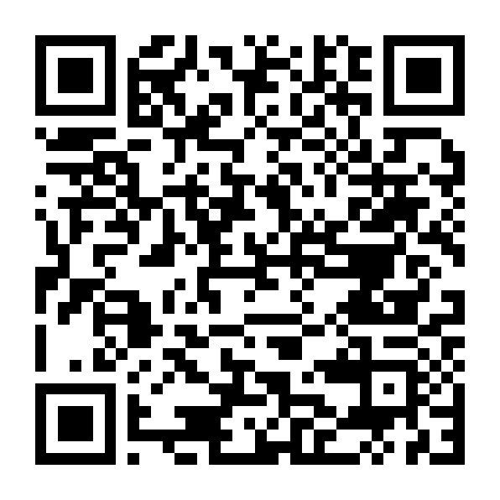

Thank you for your participation!