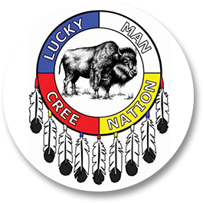
ATTN: LMCN Members
Date: June 3, 2024
LMCN Request for Catering Services

LMCN Chief and Council is inviting Band Members to submit a proposal to provide catering services at the upcoming Treaty Day Events held at Lucky Man Cree Nation on the following dates July 3,4, and 5th, 2024.
Deadline: June 11th, 2024
Each submission bid must contain the following:
- Diabetic and Elder Friendly (menu each day Breakfast, Lunch and Supper also Snacks)
- Number of guests per day will vary (approximately 80)
- Pricing ex. Cost per plate
- Coordinating with the scheduling of an event
- Preparing and serving the food
- Must have own transportation to go shop and take back to Luckyman etc.
- Setting up and cleaning serving area
- Cleaning up all areas utilized by caterers i.e. Kitchen, Stove, Barbeque etc.
- Have own catering equipment
- Include drinks, coffee, tea, water, fruit, vegetables, and snacks in quote.
The successful candidate will also need to cook for an evening barbeque which is scheduled for July 4th. That menu has been pre-determined and consists of Hotdogs, Hamburgers, Chicken Breast (or similar nutritional value-diabetic friendly) and the sides can be at the discretion of the caterer (i.e. corn on the cob, beans, coleslaw, Bannock)
The caterer will also be responsible to prepare and cook the BBQ foods for lunch on July 5th. Steak, baked potatoes and Caesar salad. This meal will not be included in the quote as Luckyman will provide the food.

For any further information required or to submit your proposals please contact Band Manager Crystal Albert via email lucky.man.band.office@sasktel.net or by phone 306-374-2828 or Richard Okemow via email richard.okemow@luckymancree.com or by phone 306-490-2479.
Thank you for your time and Interest.

