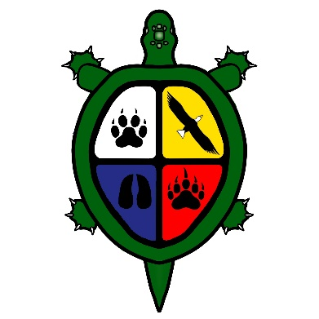

Lucky Man Cree Nation Coffeehouse for Discussions and Information Share

Lucky Man Cree Nation Leadership invites all our members to participate in our Coffeehouse for Discussions and Information Share, hosted by Lucky Man Leadership and Battle River Indigenous Relations Council (Battle River IRC).
Battle River IRC will be on-site, with informative booths and tables so that membership can learn and share feedback about:
- Nation Rebuilding Update
- RIRSD Table and Discussion Groups
- Infrastructure Update
WHEN: February 15th, 2024, 5-7pm (our coffeehouse is happening the night before our LMCN Project Wâhkôhtowin Language Camp – please see the language camp invitation)
WHERE: Don Ross Centre - Gym Lobby, North Battleford, SK
St Thomas Dr, North Battleford, SK S9A 0N8

Join us in building relationships and getting connected!
Your participation will help us make positive and responsible decisions for our Nation, today and in the future.
For more information, please contact: Jayneika Okemow-Bull
Email: admin@battleriverirc.ca or mobile 1 (306) 490-2982
Dinner!
Prize Draws!

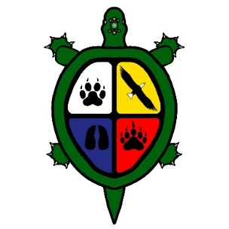

Lucky Man Cree Nation Coffeehouse for Discussions and Information Share
Thursday, February 15th 2024
4:30pm-5:00pm | Set up
5:00pm-5:30pm | Opening Prayer – Elder  Opening Remarks – Chief Crystal Okemow
5:30-6:30pm | Buffet Dinner and Community Conversations  - Nation Rebuilding Update  - RIRSD Table and Discussions – Led by LMCN Working Group  - Infrastructure Update – Led by LMCN Project Management Team
6:30pm-7:00pm | Closing Remarks – Chief Crystal Okemow  Closing Prayer – Elder TBD

* Hotel Rooms will be provided for participants who live more than 50km out-of-town AND plan to attend the Project Wâhkôhtowin Language Camp (from Thursday Feb 15 to Monday Feb 19). We have a limited number of rooms and will be providing rooms on a first come, first serve basis. Hotel room recipients must attend Project Wâhkôhtowin Language Camp.
*Shuttle: If you need a ride to the Coffeehouse or to book a hotel room, please contact Jayneika Okemow Bull before February 12, 2024.
* Mileage will be provided for out-of-town participants

