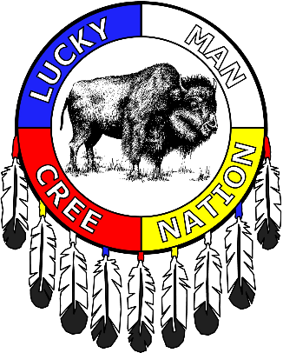
Lucky Man Cree Nation
Head Office: 520 Heritage Way
Gold Eagle Indian Reserve
North Battleford, SK. S9A 0P2
Saskatoon, SK. S7N 4K4
P: 306-374-2828
F: 306-934-2853
E: lucky.man.band.office@sasktel.net
W: www.luckymancree.com

November 24th, 2022
Tansi Kakeyow,

Leadership is pleased to announce that there will be a Lucky Man Christmas meal held in Saskatoon at the following location:

When: Saturday, December 10th, 2022
Location: Hilton Garden Inn, Saskatoon Downtown by TCU
Room: Estevan Room (lower level-accessible by elevator)
Address: 90 22nd Street East, Saskatoon, S7K 3X6 P: 306-244-2311
Doors open/setup: 2:00pm
Entertainment: Hypnotist 3:00pm- 4:30pm
Mealtime: 4:45pm
Photo booth: 3:00pm - 6:30 pm
Turkey Distribution courtesy of Darius Albert:6:00 - 7:00 pm

Santa is expected to drop off a gift for membership, if you can not make the meal, please provide written permission to the person you are allowing to pick up on your behalf.Santa cannot release his gifts without written signed permission. If you have a child(ren) in your care, please state that they are picking up on their behalf as well.
Pauline Okemow is Lucky Man Indian Registry Administrator and will be on hand to do status cards for Lucky Man band members.

We will also have CIBC on hand for meet & greet and for questions. CIBC is the trustee for the Legacy Trust and they directly handle the minor distribution for the youth members when they turn 18 years old.

A shuttle will be provided for North Battleford members that need a ride, please forward your name by December 2nd 4:30pm to Jayneika at the BRIRC at 1-306-490-2982. Please note space is limited so guarantee your spot asap.

Should there be questions, concerns or for clarification on these details please call the Band Office at: 1-306-374-2828 or email lucky.man.band.office@sasktel.net

Please remember to provide the band office with your most recent and updated contact information.

Chief, Council and Staff of Lucky Man Cree Nation wish a Merry Christmas to one and all. May the holiday season bring happiness and joy to your home fire. And may the New Year bring good health and prosperity 🎅🏽🤶🏽🎄

Safe travels to all, throughout the holiday season 💫

Sincerely,

Chief Crystal Okemow & Council
Lucky Man Cree Nation

Please Note: We have a newFacebook page under Lucky Man Cree Nation. Please look for any updates for Lucky Man Cree Nation on the Facebook page, or website www.luckymancree.com

Please update the band officeof any changes to your address or contact info at 1(306) 374-2828

